THE IMS1270 CIPS USER'S MANUAL (3)
Appendices

Customizable Ion Probe Software

Version 4.0

CONTENTS
end of contents
1. (Introduction) 5
2. (The [M, B] table) 5
3. (Starting the instrument) 5
4. (Checking the instrument before an analysis) 5
5. (Defining and Running an isotope analysis) 5
6. (Other Analyses) 5
7. (Displaying and processing the Isotope analysis results) 5
8. (The EM Control and EM drift correction) 5
9. (The stage Navigator (HOLDER)) 5
10. (Image Processing) 5
11. (TOOLS) 5
12. Appendices 6
12.1 Appendix 1: The EM Physical principles 6
12.1.1 Overview 6
12.1.2 EM output and discriminator threshold 6
12.1.3 Dead time and Yield corrections. Dependance on the gating 8
12.1.4 EM aging 9
12.1.5 The EM electronic dead time adjustment 11
12.2 Appendix 2: The EM drift correction principles 11
12.2.1 Introduction 11
12.2.1.1 Overview 11
12.2.1.2 Example of EM drift measurement 12
12.2.2 Processing 12
12.2.2.1 Introduction 12
12.2.2.2 Before analysis, S(Thr) overall featuring σ and α calculation 13
12.2.2.2.1 Processing Description 13
12.2.2.2.2 Example. 13
12.2.2.3 Before analysis, S(Thr) fine modelization, β and λ computation 14
12.2.2.3.1 Processing description 14
12.2.2.3.2 Example 14
12.2.2.4 During analysis, determining the current σ and therefore the yield drift 15
12.2.2.4.1 Processing Description 15
12.2.3 Computation routines 16
12.2.3.1 Sigma et alpha computation routines 16
12.2.3.2 sigma computation routine, alpha being kept constant 16
12.2.3.3 Lambda et Beta computation routines 17
12.3 Appendix 3: The QSA effect 17
12.4 Appendix 4: The Faraday cup Measurement principle 17
12.4.1 The Faraday cup description 17
12.4.2 The FC resolution and thermal drift 18
12.4.3 The FCs Channel settling time . 18
12.5 Appendix 5: Fundamental of Statistics 20
12.5.1 Binomial law, poisson law, Normal law 20
12.5.2 Properties of the normal law 21
12.5.3 Consequence for the ion counting 23
12.6 Appendix 6: LabVIEW® graph options and graph cursors 23
13. Questions 24
end of contents

Contents ↑

(Introduction)
See The IMS 1270 CIPS user's guide (1)

(The [M, B] table)
See The IMS 1270 CIPS user's guide (1)

(Starting the instrument)
See The IMS 1270 CIPS user's guide (1)

(Checking the instrument before an analysis)
See The IMS 1270 CIPS user's guide (1)

(Defining and Running an isotope analysis)
See The IMS 1270 CIPS user's guide (1)

(Other Analyses)
See The IMS 1270 CIPS user's guide (1)

(Displaying and processing the Isotope analysis results)
See The IMS 1270 CIPS user's guide (2)

(The EM Control and EM drift correction)
See The IMS 1270 CIPS user's guide (2)

(The stage Navigator (HOLDER))
See The IMS 1270 CIPS user's guide (2)

(Image Processing)
See The IMS 1270 CIPS user's guide (2)

(TOOLS)
See The IMS 1270 CIPS user's guide (2)

Contents ↑

Appendices

Appendix 1: The EM Physical principles

Overview
The IMS 1270 is equipped with electron multipliers (EM) working in a direct pulse counting mode.
- An AF150H EM, manufactured by ETP is mounted on the main axial detection block. It is made of 21 active film dynodes.
- The multicollector trolleys are equipped with R4146 EM, manufactured by Hammamatsu. R4146 is made of 16 CuBeO dynodes.
- The multicollector trolleys can also be equipped with ETP AF151H, smaller than AF150H, with only 19 dynodes.

A secondary ion striking the first dynode (conversion dynode) of the EM induces a secondary electron emission. Then, these electrons are accelerated through the successive dynode stages in order to amplify the secondary electron current. A gain (mean number of electron per secondary ions) of about 10⁸ is obtained. For most of the secondary ions reaching the detector, a charge pulse is produced at the last dynode output. The charge amplitude is converted in voltage, and the pulse amplitude, in Volt is proportionnal to the EM gain. Note that some incident ions do not produce any signal at the EM output (See below the sections § EM output and discriminator threshold ).

It may occur that two or more ions impinge the EM first dynode within a time interval small enough to be detected as a single ion. This effect is known as EM dead time and is developed in the section §Dead time and Yield corrections. Dependance on the gating.

The amplitude of every pulse is randomly distributed according to a distribution law currently displayed by the PHA Distribution Curve (PHA states for Pulse Height Amplitude). The knowledge of this distribution is therefore very helpful to optimize the setting of the EM High Voltage (HV), and Threshold (See the section § EM output and discriminator threshold). Checking this curve shape also used for controlling the EM aging (See the section § EM aging).

Contents ↑

EM output and discriminator threshold
Definitions
Due to the statistical variation of the secondary electron emission, every secondary ion reaching the first dynode of the electron multiplier does not produce the same number of electrons. Note that the percentage of those producing at least one electron is called DQE (Detection Quantum Efficiency).
More generally, the ion/electron conversion efficiency corresponds to the response of the first dynode. It includes the DQE, and the P(k) distribution law which gives the probability for one ion to produce k electrons. The ion/electron conversion efficiency depends on the incident ion features: mass, velocity and nature (single or molecular) species.
The EM gain is the ratio between the electron output current and the ion input current. It involves both the first dynode ion/electron conversion efficiency and the other dynodes amplification effect. This last amplification depends on the EM HV and also on the EM age.
The PHA distribution is the probability P(V) for an EM output pulse to have a voltage amplitude V. As the EM gain, it depends also on both the first dynode ion/electron conversion efficiency and the other dynode amplification effect.
The EM Yield is the ratio between the number of output pulses counted after the EM discriminator (see below) and the number of incident ions.

The EM detection channel
The first electrons produced by the first dynode when impinged by an ion are amplified by the successive stages the electron multiplier with a gain in the range of 10⁸ (EM gain). As it is displayed on a PHA distribution curve, the pulses detected at the EM output do not have the same amplitude (see the figure below). A preamplifier converts the charge pulses into voltage pulses and amplifies them. Then, a discriminator selects the pulses larger than a given threshold.
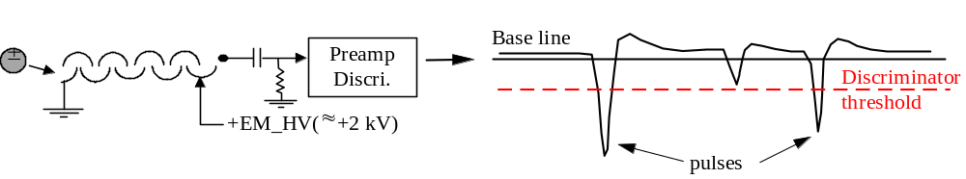

Typical PHA distribution curve 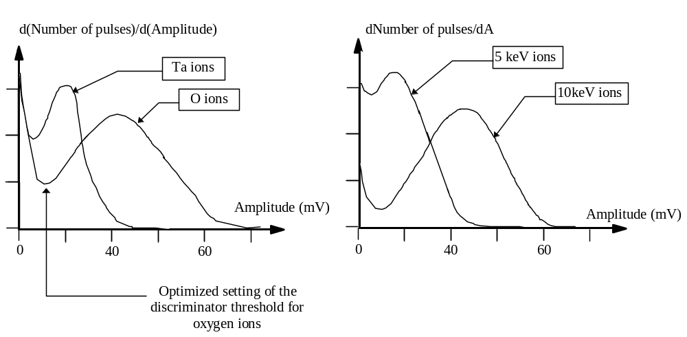

The large number of pulses with a small amplitude (first part of the pulse amplitude distribution) are due to the system noise. These pulses are therefore eliminated by using a discriminator with an adjustable threshold. The setting of the threshold is the result of an optimization which minimizes the EM background ( typically < 5 counts/mn) and to EM detection efficiency (number of counted pulses per secondary ion). This optimized threshold corresponds to the first minimum of the PHA distribution curve. For displaying a PHA curve, See the main CIPS user's manual, § Tools/The EM PHA

Note that, for instance, when the secondary ion extraction voltage is varied the discriminator threshold should be re-adjusted in order to work under optimized conditions.

Contents ↑

Dead time and Yield corrections. Dependance on the gating
Dead time τ
At a given accuracy, the highest secondary ion intensity which can be measured is limited by the time resolution of the pulse counting system. The so-called dead time of the pulse counting system is the time spent after each event before being able to detect the next one.
Let N_{c} the number of counted pulses per second at the pulse counting system, and τ the dead time of this system. Assuming that the system was unabled during N_{c}*τ, it is possible to deduce the EM output count rate N'

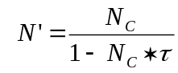

This is the basic dead time correction formula. For a dead time of 25 ns and a true pulse rate of 10⁶ pulse/s, a dead time correction of 2.4 % must be applied to the counted rate. As it can be easily corrected by a mathematical formula, the EM dead time is not an instrument limitation, providing τ is precisely known. That is why a delay line circuit is implemented on the discriminator board. Switches on this PCB allow to set the dead time (See the User's guide for Multicollector)

EM detection Yield Y_{EM}

The EM detection Yield Y_{EM} is defined as
Y_{EM} = (EM output pulse rate/EM input ion rate)

It can be measured on the instrument by comparing the measured EM count rate and the FCs count rate in the range of 10⁶ c/s.

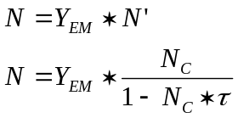

The deadtime correction depends also on the gating
Some analyses may be achieved with an optical or an electronic gating. It consists of rastering the primary spot and masking (either by optical means or by electronic means) the secondary ions generated outside of a central zone of the rastered frame. It is worth to emphasize that whenever either optical or electronical gating is set. The instantaneous count rate, within the gate, can be much larger than the measured count rate averaged over a frame. The dead time correction must therefore take into account the ratio η_{GATE}

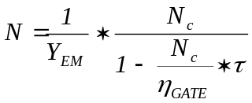
The ratio η_{GATE} is the area ratio gate/frame, so that N_{C}/η_{GATE} is actually the instantaneous count rate since N_{C} is the count rate averaged over the whole frame while all the counts occur only over the gate.
For determining η_{GATE}, both electronical and optical gate must be considered.
- In the electronical gate case, the calculation of η_{GATE} is quite straight. For example, if the electronical gate is determined as a square of p x p pixels within the 1024 x 1024 frame.
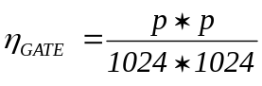
- In the optical gate case, both the raster size and the Analysed area must be correctly calibrated. The raster size is defined as the as the scanned field size, in µm at the sample planein the case of a punctual primary spot. The Normal Area is defined as the sample field diameter limited by the Normal field aperture size. So, the Analysed area is simply defined as
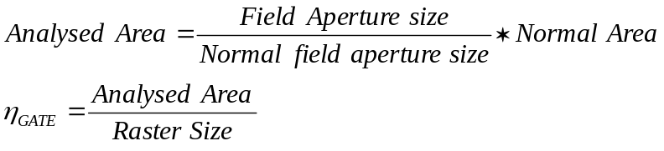

Contents ↑

EM aging
When an EM is getting older the EM gain (output electrons per ion) decreases , leading to a Y_{EM} decrease if the EM HV is kept constant. For recovering the original gain and yield, The EM HV must be increased (See the figure below)
Note that the life time of an electron multiplier depends on the gain and the total number of ions counted (total integrated charge). Frequent high intensity measurements shorten the EM life time.

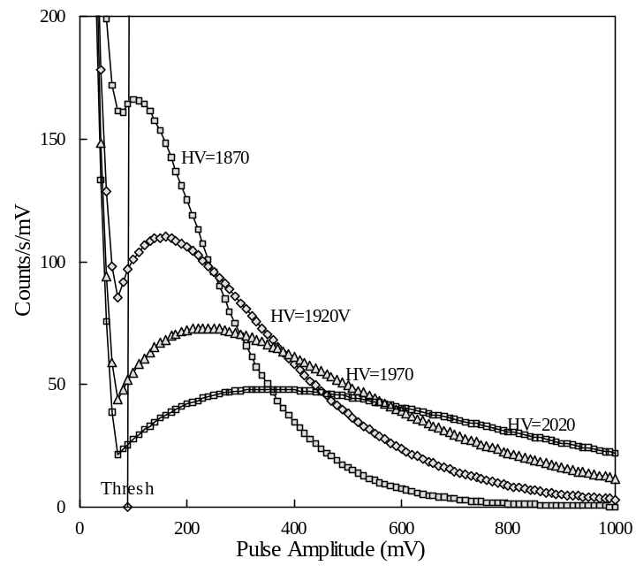 | THE EM PHA  Distribution Curve  The PHA distribution curve is obtained by scanning the discriminator voltage from O to 1000 mV. The obtained curve is then derivated.  Different plotted curves correspond to different EM high Voltages.  The aging effect is equivalent to an EM HV decrease so that the aging must be compensated by increasing the HV Voltage.

Contents ↑

The EM electronic dead time adjustment
The preamplifier / discriminator assembly is shown in the hereunder image. It can be noticed that the preamplifier and the discriminator are independently shielded in order to reduce the electronic noise of the overall system.

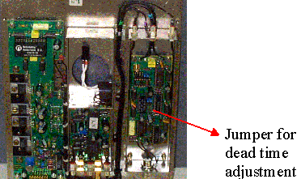

The dead time value is adjustable by positioning a jumper . The available dead time values are : 20, 24, 28, 36, and 40 ns.. The jumper label on the board is TB2. The jumper position corresponding to 20 ns is at the top. The dead time value is the sum of the delay time (determine by the delay line) and the extra time for the signal propagation.

Dead Time = 2* delay_line + 4ns (propagation time)
Dead time (ns) | Delay line (ns) | Jumper position
20 | 8 | 1 (top)
24 | 10 | 2
28 | 12 | 3
36 | 16 | 4
40 | 18 | 5 (bottom)
For most of the applications the jumper position #2 is recommended.

Contents ↑

Appendix 2: The EM drift correction principles

Introduction

Overview

The EM Y_{em} Yield is the counted electrons/incident ions ratio. As a matter of fact, Y_{em} corresponds to the rated working discriminator threshold which is called Thr1 in this document. It is wellknown that Y_{em} drifts down along the time when yhe incident ion rate is large. This is a big issue in the case of an isotopic ratio measurement achieved in the multicollection mode, since the different EMs, which received different ion intensity, will not drift at the same rate.
The first approach in order to by-pass this drift effect is to run frequently a standard sample, but a counterpart of this method is to require a motion of the sample holder. Moreover, a high precision of the drift estimate requires for the standard measurement duration to be practically as long as the sample measurement.
The method which is considered in this section is an intrinsic measurement of a given EM drift, targetted for correcting the data. Typically, along a one hour analysis, drift measurement could be run automatically every 6 minutes, and the data acquired during the last six minutes would be corrected, by taking into account the drift measurement.
The correction method is derived from a model taking into account the assumption that the EM drift is basically an homothetic shrinking of the curve S=f(Thr) which is easily recorded by scanning the threshold Thr and measuring the EM signal S. The drift phenomena transforms S=f(Thr) into S=f(k*Thr), k>1. What is usually called PHA is the derivative of S=f(Thr).
The method main idea is to measure the shrinking k, not at the working threshold Thr1, since the S variation is very low in its neighbourhood, but at Thr3, a threshold such as S(Thr3) is close to S(Thr1)/2. the method is therefore unsensitive to any incident ion beam drift, resulting from a primary beam drift or any other cause.

Example of EM drift measurement
The 3 S(Thr) curves plotted hereunder have been recorded on an IMS1270 multicollector R4146 EM. These curves are normalized so that S(Thr1)=100.
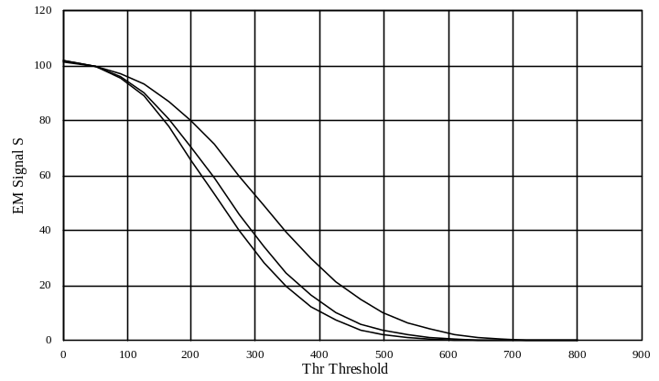

Init (left hand side) is the curve recorded at thetime t₀, while Drift1 (midle) was recorded at t₀+1hour and Drift2 (right hand side) at t₀+3hours. The ion rate was several hundred of thousands counts per seconds. This plot shows that obviously, the shrinking k can be measured easily in the middle region while it would be more tricky at the neibourhood of Thr1=50.
Contents ↑

Processing

Introduction
The different processing stages are presented hereunder. This processing requires a limited number of measurement points,
On présente ci-dessous les différentes phases du traitement. Ces différentes phases ne requièrent qu'un nombre limité de points de mesures (S, Thr), mais à chaque étape, pour justifier et discuter le traitement proposé, on est amené à considérer l'ensemble des courbes S(Thr) qui ont été présentées en guise d'exemple.
Pour coder le traitement, il suffit de lire les sections (desciption du traitement)

Before analysis, S(Thr) overall featuring σ and α calculation

Processing Description
Thr1 is the working threshold, set during an analysis.
Thr3 is a threshold such as S(Thr3) is close to S(Thr1)/2.
Thr4 is a threshold slightly larger than Thr3. (Typ, Thr4=1.11*Thr3)

- S1=S(THr3), S1=S(THr3), S4=S(THr4), S3 and S4 are normalized at S1=100.
- σ et α parameters are caculated so that the relationship
 | 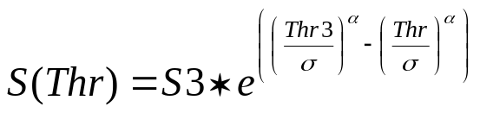 | (1)

is checked for the 3 points (Thr1, S1), (Thr3, S3) and (Thr4, S4) .

The σ and α computation routine accepting these 3 points as input is described further in the section § sigma et alpha computation routine

Contents ↑

Example.
In the proposed routine, only 3 points are measured. However, for demonstrating the method relevancy, all the S(Thr) curve is considered in this section. The hereunder plot shows that
- α=2.5 and σ=357.3 make it possible to rebuild the overall init curve.
- Keeping the same α=2.5, a new value of σ makes it possible to rebuild the overall drift1 and drift2 curves (σ=302.59 et σ=284.21)

In the hereunder plot, lined curves, corresponding to measurement, are the same as in the previous plot while symbol points are calculated according the analytic formula (1).

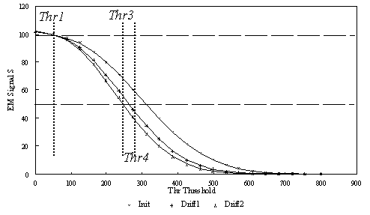

A first look on the plot may suggest that the experimental measurements are correctly modelized by the analytical relationship (1), but a finest look close to the working threshold (Thr1=50 mV) does not demonstrate a good fitting in this region.

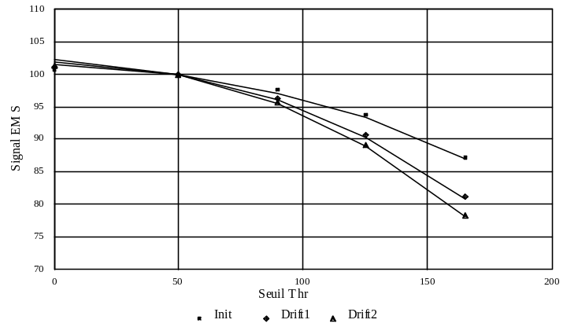

Analytical relationship (1) gives, for Drift2, S(0)=101.31, instead of 102.2, that is an underestimate of 50% of the actual drift. A finest analytical model must therefore be used in the working region.
Contents ↑

Before analysis, S(Thr) fine modelization, β and λ computation

Processing description
Additionally to the point (S1, Thr1), one takes into account 2 other points (S0, Thr0) and (S2, Thr2) located on both sides of Thr1. Typically
Thr0 = Thr1-(Thr3-Thr1)/10
Thr2 = Thr1 + (Thr3-Thr1)/10

- Both S0=S(Thr0) and S2=S(Thr2) intensities must be measured. (practically, the five intensities, corresponding to Thr0, Thr1, Thr2, Thr3 and Thr4 will be measured in the same routine)
- β and λ parameters are computed so that the relationship
 | 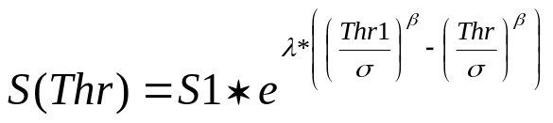 | (2)

is checked for the 3 points (Thr0, S0), (Thr1, S1) et (Thr2, S2) .

The β and λ computation routine accepting these 3 points as input is described further in the section § Lambda and Beta computation routine

Example
In the hereunder table, columns 2, 3 and 4 are measurements while columns 5, 6 and 7 are calculated according to the analytical expression (2) with the numerical values of σ, β and λ which are displayed in the table.
Thr | meas init | meas  drift1 | meas  drift2 | Calcul (1)  init | Calcul (2)  drift1 | Calcul (2)  drift2
0 | 101.48 | 101.81 | 102.20 | 101.48 | 102.03 | 102.29
50 | 100.00 | 100.00 | 100.00 | 100.00 | 100.00 | 100.00
90 | 97.04 | 96.01 | 95.60 | 97.04 | 95.97 | 95.47
 |  |  | σ | 357.3 | 302.59 | 284.21
 |  |  | β | 1.895 | 1.895 | 1.895
 |  |  | λ | 0.61 | 0.61 | 0.61

For understanding correctly this table, it must be clear that β and λ have been computed once only before the analysis, and that only σ is re-computed along the analysis. The last analytical model (2) fits fairly better the measurement at the neighbourhood of Thr1.
Whenever a measurement of σ is achieved, the yield can be deduced, by assuming that the S(Thr) curve is shrinked of a factor σ/σ_{i} , σ being the value calculated along the analysis, and σ_{i} the value calculated before the analysis. This computation processing is described in the next section.

Contents ↑

During analysis, determining the current σ and therefore the yield drift

Processing Description
Along an analysis, whenever the yield is to be estimated again, the two points S(Thr1) and S(Thr3) are only required to be measured.
- The threshold is successively set to Thr1 and Thr3, S1=SThr1) and S3=Sr3) are measured and normalized to S1=100.
- Parameter σ is calculated so that the relationship (1)
is checked for both points (Thr1, S1) and(Thr3, S3). α is kept to its previously determined value. This routine for computing σ is described below in the section § sigma computation routine, alpha being kept constant

- The Yield is derivated from the formula
 | 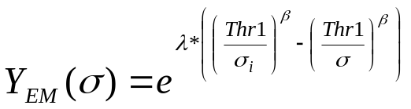 | (3)
σ_{i} and λ being kept to their previously determined value.

Regarding the considered example:
For Drift1: Y_{EM}=99.46%
For Drift2: Y_{EM}=99.21%

Computation routines

Sigma et alpha computation routines
Let (Th1, 100), (Th2, y2), (Th3, y3) be a set of 3 points so that Th1<Th2<Th3 and 100>y2>y3 (attention, in this section, the indexes, 1, 2, 3, may have not the same meaning as in the previous sections.)
The routine targets to determine the hereunder function parameters α and σ
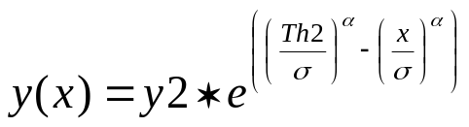

y(x) must be checked for the 3 points. Note that this function is always checked for (Th2, y2), for any α and σ.
The issue is therefore to determine α and σ for checking the relationship for (x=Th1, y=100) and (x=Th3, y3). (α, σ) are initialized to (2.5, Th2) and then an iterative calculation is carried out. Let (α', σ') be the new values calculated at the step i+1, from the step i (α, σ) values:
σ' = σ * (1 – 0.5 * (y(Th1)-100)/(Th1-Th2))
α' = α * (1 + 1 * (y(Th3)-y3)/(Th1-Th2))
The iterative calculation stops when

⎜ (σ-σ')/σ ⎜<0.001 and ⎜ (α-α')/α ⎜<0.001
And then
σ = σ'; α = α'

maximum number of loops : 50

sigma computation routine, alpha being kept constant
Let (Th1, 100) and (Th2, y2) be a pair of 2 points so that Th1<Th2 and 100>y2 (attention, in this section, the indexes, 1and 2, may have not the same meaning as in the previous sections.)
The routine targets to determine the hereunder function parameter σ, α being kept constant

y(x) must be checked for the 2 points. Note that this function is always checked for (Th2, y2), for any σ.
The issue is therefore to determine σ for checking the relationship for (x=Th1, y=100).
σ is initialized to Th2 and then an iterative calculation is carried out. Let σ' be the new value calculated at the step i+1, from the step i value of σ:

σ' = σ * (1 – 0.5 * (y(Th1)-100)/(Th1-Th2))
The iterative calculation stops when

⎜(σ-σ')/σ ⎜<0.001
And then
σ = σ'

Maximum number of loops : 50

Lambda et Beta computation routines
Let (Th0, y0), (Th1, 100), (Th2, y2) be a set of 3 points so that Th0<Th1<Th2 and y1>100>y2
The routine targets to determine the hereunder function parameters λ and β

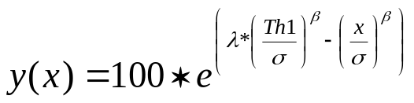

y(x) must be checked for the 3 points. Note that this function is always checked for (Thr1, 100), for any λ and β.
The issue is therefore to determine λ and β, σ being given, for checking the relationship for (Thr0, y0) and (Thr2, y2). (λ, β) are initialized to (2.0, 0.6) and then an iterative calculation is carried out. Let (λ', β') be the new values calculated at the step i+1, from the step i (α, σ) values:
β' = β - 10 * (y(Th0)-y0)/(Th0-Th1)
λ' = λ + 4 * (y(Th2)-y2)/(Th2-Th1)
The iterative calculation stops when
⎜(β-β')/ β)⎜<0.001 ; ⎜(λ-λ'/λ⎜<0.001
And then
β = β'; λ = λ'

maximum number of loops: 100
Contents ↑

Appendix 3: The QSA effect
The QSA (Quasi Simultaneous Arrivals) effect may be to be taken into account for the EM counting, additionally to the deadtime correction.
Secondary ions are often considered to be only a small fraction of the bunch of sputtered particles resulting from the impact of a single primary ion. However, for some applications, which combines both high ionization yields (by using Cs⁺ primary ions for instance) and high collection efficiencies, the average number K of secondary ions (of a given species) ejected per primary ions may reach values as high as 20% for some elements. In such conditions, the probability to get more than one secondary ion per primary impact is not negligible so that one must contemplate situations where a single primary impact produces two secondary ions, which in return infers that those ions will arrive at nearly the same time on the conversion dynode of the electron multiplier (EM). Quasi-simultaneous arrivals (QSA) are registered as single pulses so that the registered number of counts is slightly lower than the actual number of incoming ions. Assuming a Poisson statistics, the correction factor is given by (1 + K/2) in a first order approximation. In the case of an EM measurement of the complete set of Oygen Isotopes (¹⁶O, ¹⁷O, ¹⁸O), with wellknown abundancies of (2000, 1, 4), ¹⁶O must be corrected for the QSA effect whereas corrections will be completely negligible for ¹⁷O and ¹⁸O, the low abundant isotopes. Similar observations can be made for others elements like carbon, silicon or sulfur. It should be emphasized that the QSA effect is not linear with the mass difference between isotopes and does not depend upon the counting rate.

Reference: G. Slodzian, M. Chaintreau, R. Dennebouy and G. Rousse : Precise in situ measurements of isotopic abundances with pulse counting of sputtered ions. EPJ Applied Physics, 14, n°3, 199, June 2001

Contents ↑

Appendix 4: The Faraday cup Measurement principle

The Faraday cup description
The Faraday cup is an hollow cylinder with large ratio length/diameter isolated from the instrument ground. In order to measure accurate secondary ion intensities it is mandatory to prevent the secondary electrons induced by the ion bombardment of the Faraday cup walls from escaping of the Faraday cup. This is achieved by placing a repeller (a plate negatively biased) in front of the Faraday cup.

A schematic drawing of the IMS Faraday cup system is shown in the here under figure :

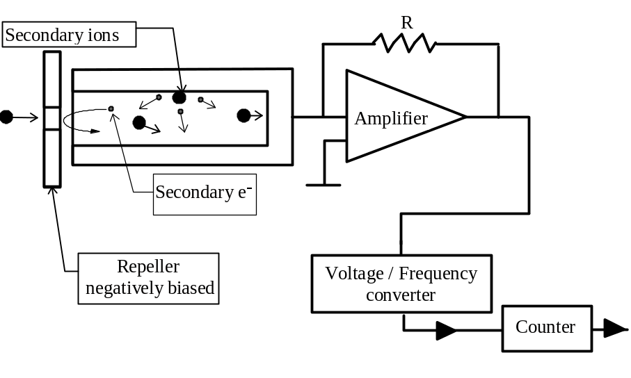

The charges brought by the secondary beam focused into the Faraday cup produces a current which is converted into a voltage by a high impedance amplifier. This voltage is sent at the input of a voltage/frequency converter.

The FC resolution and thermal drift
The maximum input voltage of the V/F converter is 10 V and the resistor R is of 10¹⁰Ω for the FC1 amplifier, 10¹¹Ω for the standard multicollector amplifiers. The maximum count rate which can be measured with the multicollector Faraday cup s therefore

Imax = 10 /(10¹¹ x 1.6 10⁻¹⁹ ) = 6 x10⁸c/s

The typical thermal drift is 400 c/s/°C for the multicollector, and 4000 c/s/°C for FC1

In order to work in the linear range of the V/F converter an offset is applied on the preamplifier (typically equivalent to few Millions of c/s). The intensities measured by means of the Faraday cup must be corrected of the offset (See the Software user's guide, )
The polarity of the preamplifier is automatically adjusted by the automation system according to the polarity of the secondary ion beam.

The FCs Channel settling time .
The FCs channel response time order of magnitude is of one second with a 10¹¹Ω resistor and 0.1 second with a 10¹⁰Ω resistor. Any Faraday cup measurement involved within an analysis must therefore take into account both the Faraday channel T_{fcs} time constant and the required precision prec.

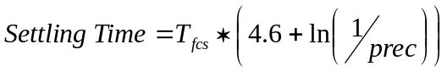
prec is expressed in %.

That leads, for the multicollector 10¹¹Ω resistor, to
Settling Time=4.6 seconds if prec=1%
Settling Time=9.2 seconds if prec=0.01%

Contents ↑

Appendix 5: Fundamental of Statistics

Binomial law, poisson law, Normal law
The binomial law
A is an event which may occur along a test. If A does not occur, the opposite event B occurs. p is the probability that A occurs. So the probability of B is q=1-p

Let run n tests. Let be P_{n}(k) the probability that A occurs exactly k times (and thus B, n-k times)

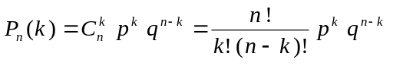

Let's assume now that n is a large number. It is possible therefore to calculate the mean and its spread σ.
= np
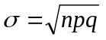
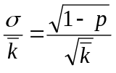

if p is very small
 | 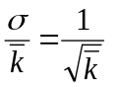 | (1)

The Poisson law and the Gauss law or Normal law

This very simple relationship can also be deduced from the Poisson law which gives P_{n}(k) when n is large

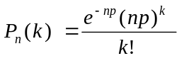

When n is very large, P_{n}(k) can be estimated by the Gauss law, also called Normal law.

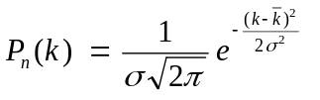

As a matter of fact, (1) can also be deduced from the Gauss law.

Properties of the normal law
Calculating the uncertainty of a measurement

So far it is established that the result R of a given counting test must follow the normal law

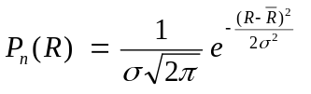

Let's define σ as the measurement uncertainty.

Let X₁, X₂, ... X_{i}, ... , X_{N} the actual results of N tests. The better estimation of σ which can be made with these 9 results is

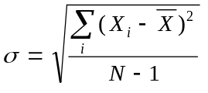
It is called the sample standard deviation or experimental standard deviation and currently written STDE.

Confidence interval
If a serie of n tests for determining gives an arithmetic mean of , so far the normal law is observed, there is a probability of 95% that the interval
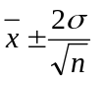
contains the actual mean x₀.

More generally, if a serie of n tests for determining gives an arithmetic mean of , there is a probability Θ(k) that the interval
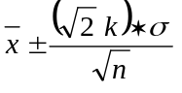
contains the actual mean x₀.

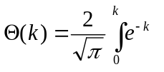

Θ(k) is called the error function.
Θ(k) | 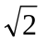k
0.9 | 1.163
0.99 | 1.821
0.999 | 2.327
0.9999 | 2.751

Estimating the accuracy of a measurement consisting of n sub-measurements

Let's define the accuracy as the standard deviation which would be observed if the measurement was repeated a large number of times.
If the sample standard deviation of the n sub-measurements is σ, the uncertainty of the measurement is
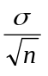
So far the statistical law ruling the n sub-measurements is actually a normal law.

Standard deviation of a Sum

Let's assume that Z=X+Y, X and Y being 2 random variables following a normal law caracterized respectivelty by their mean arithmetic value 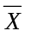 and 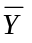 and their standard deviation σ_{X}, σ_{Y}.
Z distribution will also follow a normal law characterized by
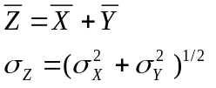

Standard deviation of a product

Let's assume that Z=X*Y, X and Y being 2 random variables following a normal law caracterized respectivelty by their mean arithmetic value and and their standard deviation σ_{X}, σ_{Y}.
Z distribution will also follow a normal law characterized by
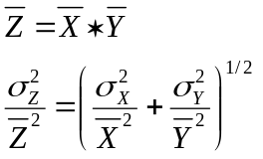

Standard deviation of a ratio

Let's assume that Z=X/Y, X and Y being 2 random variables following a normal law caracterized respectivelty by their mean arithmetic value and and their standard deviation σ_{X}, σ_{Y}.
Z distribution will also follow a normal law characterized by
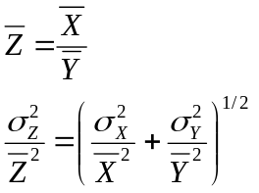

Consequence for the ion counting

When the mean number of counted ions is N during a given time τ, it can be said it is the result of repeating N*M tests for which the probability of counting one ion is 1/M. As M can be as large as desired, the formula (1) is relevant for calculating the standard deviation test result (N^{1/2}) which can be considered as the uncertainty of the test.
Consequently, when a ratio is defined as 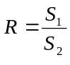, Where S₁ and S₂, expressed in counts per seconds (cps), are derived from two numbers of counts N₁ and N₂,

S₁ = N₁/T₁ S₂ = N₂/T₂
Where T₁ and T₂ are the respective counting times, accordingly to above formula giving the standard deviation of a ratio, there is an unavoidable uncertainty which can be expressed as
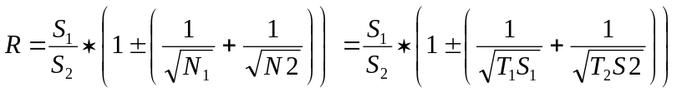

In the field of isotopic ratios, it can be relevant to define some more sophisticated ratios (for example, in the case of zircon analysis for achieving a common lead correction)

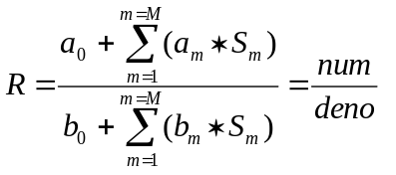
Where it is assumed that each signal S_{m} , expressed in cps, derives from a given number of counts:
S_{m} = N_{m}/T_{m}

It is possible to calculate the uncertainty of R by calculating firstly separately the absolute σ of both the numerator and the numerator (these σ are added in quadrature), and then, by adding in quadrature the relative standard deviations:

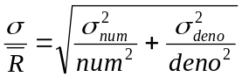

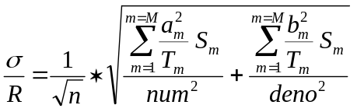

Contents ↑

Appendix 6: LabVIEW® graph options and graph cursors

Contents ↑

Questions
Q1 Amplifiers calib: Comment y accéder ?

Q2 Overlapping Crater, ça marche ?

Q3 boites pour EMDrift, Beam centering et Overlapping crater.

Q4 Comment remplace-t-on l'option Auto/Manual, pour le waiting time présente autrefois dans Analysis Definition ? Je vois 2 tableaux de masse différents. Il semble que la fonction soit présente sur l'un d'entre eux (Compute waiting time...), mais dans ce cas, pas de définition d'isotopes. Quelle est la différence entre analysis_species_table_bp.gif et analysis_species_table_monop.gif ?

AUTO/MANUAL If "Auto" is selected, the waiting time corresponding to the magnet settle time is computed according to the formula
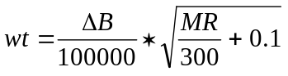
Where B is the magnetic field in digits and MR the Mass Resolution

Q6 Dans boite Analysis Definition, "Edit Last conditions" est alternatif à quoi ? et New ?

Q7 Où retrouve-t-on les fonctions autrefois accessibles à partir de Analysis Definition ?

DEFINE CONDITION (EDIT/LOAD/SAVE/SAVE AS)
EDIT loads the last analysis condition related to the current acquisition mode.
LOAD loads the analysis file selected by the operator among all the files corresponding to the current acquisition mode.
SAVE saves the analysis definition under the current filename.
SAVE AS saves the analysis definition under a new filename.

CALIBRATE (FROM TABLE/ FROM CONDITION)
Launches the Mass Calibration process
- FROM TABLE In the Mass Calibration process, for each species Mi, the magnetic field Bi will be initialized by the value as it is deduced from the current mass table [M, B]
- FROM CONDITION In the Mass Calibration process, for each species Mi, the magnetic field Bi will be initialized by the value recorded in the analysis definition species table. These recorded values are resulting from a previous calibration.

Q8 Dans le panneau "Analysis Definition" qu'est-ce qui est alternatif avec EDIT LAST CONDITIONS ? Comment ouvre-t-on Isotope box ? Elle s'ouvre en même temps que la Species table, quand on fait New dans Analysis definition ?

Q9 Est-ce que le panneau semi-auto Mass Calibration (avec Cycling, Display calib etc...) est identique au panneau Manual Mass Calibration (exception faite du bargraph) ?

Q11 Multicol: Modify Position, ça fait quoi ? Park, ça fait quoi ?

Q10 Le tableau de masse de Mass cali: Nécessite des explications détaillées, de vive voix

Q12 Panneau EM HV Adjust: En haut du panneau, il y a des champs de saisie x et y dont je ne comprends pas bien la signification. (dans set thresholds aussi)

Q13 Panneau Measure set_up: Le tableau "calibration table" concernant les amplis FC, que l'on retrouve en bas du panneau, est-il purement passif ou peut-on l'éditer ?

Q14 Panneau de contrôle Multicollection: A discuter de vive voix.

Q15 Table périodique: A discuter de vive voix.

Q16 Dans Panneau PHA, les champs de saisie "min value", "max value" ont disparu. Par quoi ont-ils été remplacés ?

Q17 Il y a un panneau "Préférences", avec "IMS 1270 with Turbo-pumps", une sélection de directory etc... ? Il faudra que j'ai la liste de toutes les options possibles.

Q18 Dans le panneau "Detection setup", Multicol waiting time, c'est quoi ?

Q19 Dans panneau "Detection Set-up", dans le menu déroulant, Detection Setup est alternatif avec quoi ?

Q19 Dans panneau "Detection Set-up", bouton "Define Set-up", c'est quoi ?

Q20 Download + Global: MOT veut bien dire qu'on charge les moteurs, et DET, les paramètres de la multico ?

Q21 petit panneau permanent L'2/L2.L1... Quit Comment ça marche ?

Q22 Stop Source: Différence entre cancel et Quit ?

Q23 Compteur de source: Set Status ? Si on fait quit, le panneau disparait, et si on veut le faire revenir ?

Q24 Dans Scan panel, Snap c'est quoi ?

Q25 Dans Scan panel, print to file, où est-ce qu'entre le filename ?

Q26 Dans la boite de définition d'analyse Multicoll (table de masses), comment se calcule le champ avant le "Trolley Centering"? Avant, on avait l'option "from table/ from condition", présente dans le premier panneau Analysis definition qui traitait différemment le Pb selon la sélection.

Q27 Single/Multi dans le panneau graphique Mass Cali

Q28 Est-ce qu'on peut sauver la table de masse avec les masses de référence ?

Contents ↑

> Q1 Amplifiers calib: Comment y accéder ?

tuning > FC_CALIB> OFFSET ou GAIN/OFFSET
>
> Q2 Overlapping Crater, ça marche ?

Jamais utilise, donc je ne sais pas,
La nouvelle fonction pre-sputering permet de changer la taille du
raster,
c'est peut-etre equivalent a la fonction Overlapping Crater.

>
> Q3 boites pour EMDrift, Beam centering et Overlapping crater
> (pas vraiment une question, je n'ai pas regardé toutes les
> boites)
>
> Q4 Comment remplace-t-on l'option Auto/Manual, pour le
> waiting time présente autrefois dans Analysis Definition ?
> Je vois 2 tableaux de masse différents. Il semble que la
> fonction soit présente sur l'un d'entre eux (Compute waiting
> time...), mais dans ce cas, pas de définition d'isotopes.
> Quelle est la différence entre analysis_species_table_bp.gif
> et analysis_species_table_monop.gif ?

le bouton Auto/Manual est remplace par compute waiting time dans le
paneau du tableau de masses. Ca marche en monocollection.
Il y a plusieurs presentations du tableau de masses suivant le type
d'analyse, mono,multi, isotope , line scan etc... j'ai du sans doute
impimer les tableau isotope multi et mono.

>
> Q6 Dans boite Analysis Definition, "Edit Last conditions"

rapelle les conditions de la derniere analyse du meme type.

> est alternatif à quoi ?
load analysis

et New ?

le bouton (racourci) est a supprimer , New de la liste <File> ouvre un
tableau vierge pour le type d'analyse choisi.

>
> Q7 Où retrouve-t-on les fonctions autrefois accessibles à
> partir de Analysis Definition ?
>
> DEFINE CONDITION (EDIT/LOAD/SAVE/SAVE AS)
dans la liste <File>
>
> CALIBRATE (FROM TABLE/ FROM CONDITION)
bouton CALIBRATE dans le paneau tableau de masses
l'option From table,condition est dans le programe de mass calib
>
> Q8 Dans le panneau "Analysis Definition" qu'est-ce qui est
> alternatif avec EDIT LAST CONDITIONS ? Comment ouvre-t-on
> Isotope box ? Elle s'ouvre en même temps que la Species
> table, quand on fait New dans Analysis definition ?

Avec Species table quand on choisi analysis type = isotope
>
>
> Q9 Est-ce que le panneau semi-auto Mass Calibration (avec
> Cycling, Display calib etc...) est identique au panneau
> Manual Mass Calibration (exception faite du bargraph) ?

le mode Manual > centage du champ a la main a l'aide du bargraph ou du
MCP.

Semi_auto : mode standart centrage par l'operateur a l'aide du scan
automatique des pics.

mode auto : = mode standart avec centrage par le soft : cache et oublie
pour l'instant.
>
> Q10 Le tableau de masse de Mass cali: Nécessite des
- explications détaillées, de vive voix

Repone a Q26 :Le champ se calcule a partir de la masse entree dans le
champ monocollection de la table multicoll. et en choisissant <FROM
TABLE> dans mass cali.

On peut aussi rentrer a la main le champ dans la premiere ligne de la
table de definition multi et choisir <FROM CONDITION> dans mass cali.
Contents ↑

